**Basics for Fluid Flow Descriptions**

1. Fundamental Physical Laws & Auxiliary Relations
   1. Fundamental Physical Laws: applicable regardless of nature of fluid or flow
      1. Three Fundamental Laws
         1. Law of Conservation of Mass --> equation of continuity
         2. Newton’s Second Law of Motion --> Momentum Theorem
         3. First Law of Thermodynamics --> Energy Equation
      2. Auxiliary Relations (Laws)
         1. I.e. Newton’s Law of Viscosity only on fluids with a molecular weight > 5000
   2. Auxiliary Relations: Specific to certain kinds of flow or fluid
2. Reference: Lagrangian vs. Eulerian
   1. Lagrangian: follow a fluid particle through its course of flow
      1. VL = v(a, b, c, t)
         1. Original position of particle
   2. Eulerian: value of fluid variable at a point given in the space
      1. VE = v(x, y, z, t)
         1. Coordinate of origin
3. Steady and Unsteady Flows
   1. Fluid flow variables by four independent variables (x, y, z, t)
   2. Steady State: fluid flow variable (i.e. velocity) independent of time -- does not change with time
   3. Unsteady state: fluid flow variables depend on time
4. Streamlines and Pathlines
   1. Streamline: line drawn tangent to velocity vector at each point in the flow field.
      1. Steady state: pathline follows streamline.
   2. Pathline: actual trajectory of a fluid element as it transfers the flow (complex)
      1. Mostly will be working in streamline in this class
5. Systems and control volumes
   1. Confined, whole system boundaries
   2. Open control volume

**Mechanisms of Momentum Transport**

Associated Readings: BSL 1.1, 1.2, and 1.7

**Basic Definitions**

Molecular Momentum Transport: due to molecular interactions

Fluid property determining this transport is viscosity, μ

Convective Momentum Transport: due to bulk flow

Fluid property determining this transport is density, ρ

1. Newton’s Law of Viscosity (Molecular Momentum Transport)
   1. No slip condition: relative velocity for a viscous fluid in contact with solid surface is zero.
   2. Consider a plate (2 parallel) stationary in beginning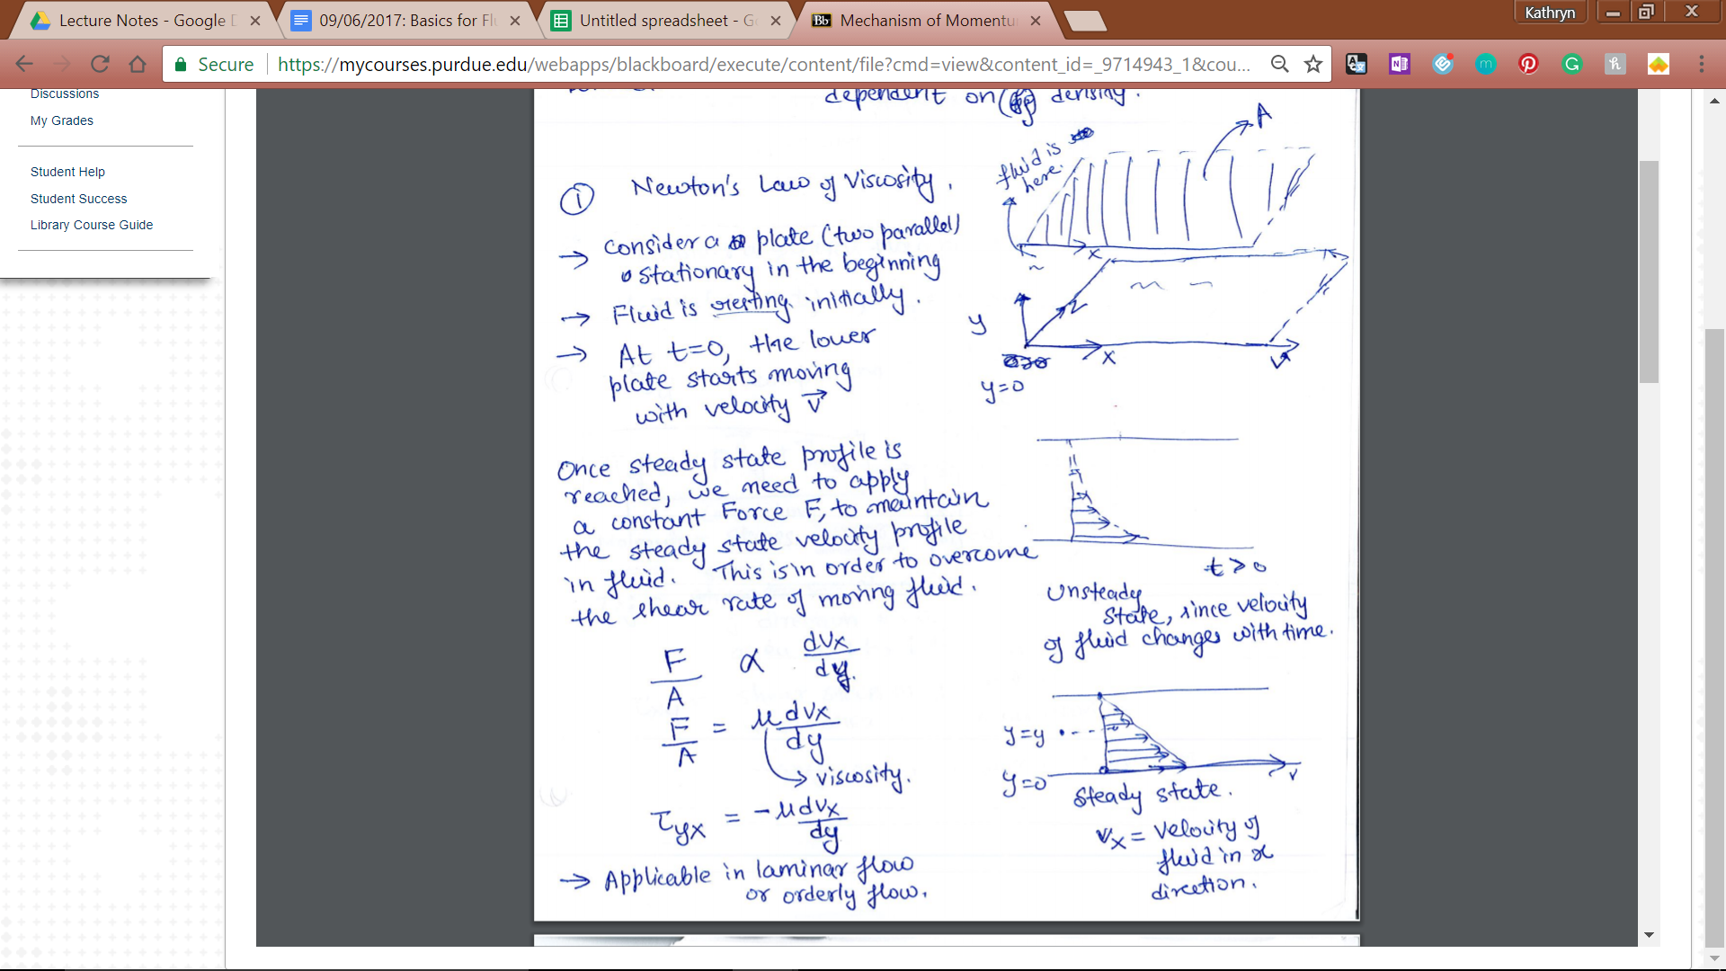
      1. Fluid is resting initially
      2. As t = 0, the lower plate starts moving with velocity, **v**
      3. As plate moves, no slip condition causes **relative velocity** of fluid at y = 0 to be 0.
      4. Momentum transferred to rest of fluid.
      5. Once steady state is reached, need to apply constant force F to maintain velocity profile in fluid to overcome shear stress of moving fluid.
      6. Unsteady state: changes with time
      7. Driving force of momentum transport: velocity gradient
      8. Applicable in laminar flow
      9. F/A = -μ dvx/dy = Ƭyx
2. Generalization of Newton’s Law of Viscosity: We generally encounter three-dimensional flows in real situations, so we need to have a general form of equation that captures the role of viscosity in momentum transfer in fluid flow. This generalization involves some assumptions which needs to be emphasized (and remembered) when using the equation. 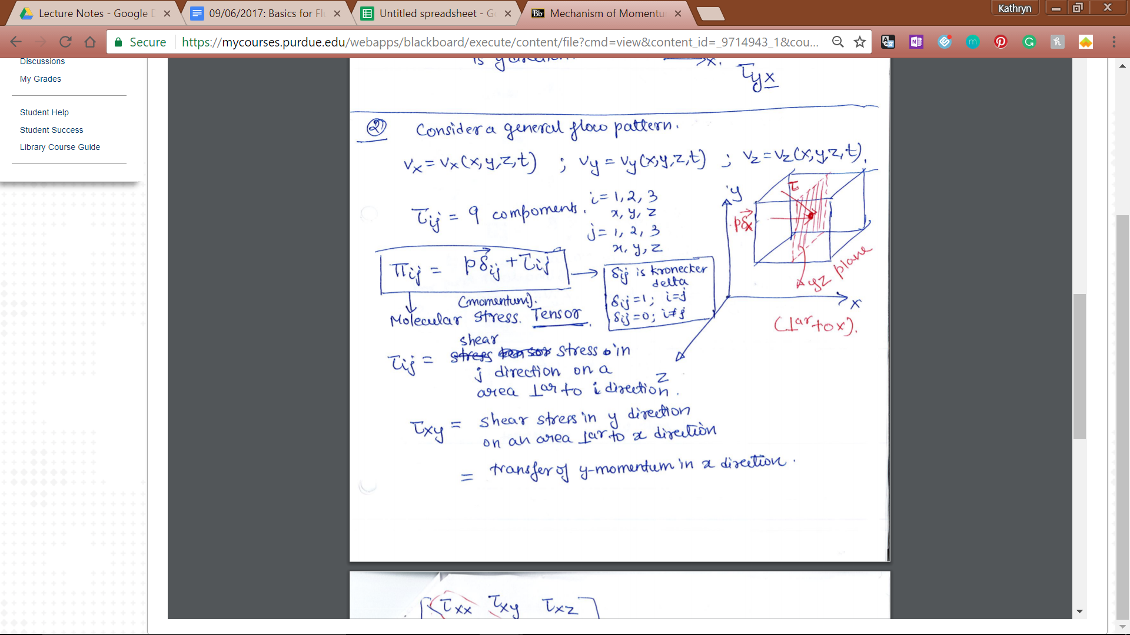
   1. Consider a very general flow pattern:
   2. There are two basic steps in this generalization approach: 1. Identifying all the forces that are acting on a fluid particle in general case and 2. Relating these forces to the velocity gradient in order to derive a relationship between forces and velocity profile. We will go over each of these steps now.
      1. Step 1: Types of Forces in a Fluid in Motion
         1. Πxx = p**𝛿**x + Ƭxx --> normal stresses in x direction
         2. Πxy = Ƭxy --> pressure not normal anymore, not a component
      2. Step 2: Relating the forces to velocity gradients
         1. Assume Ƭij = ∑k ∑ℓ μijkℓ 𝛿vk/𝛿yℓ --> i, j, k, ℓ = 1, 2, 3
         2. Linear combo of all velocity gradients
         3. (𝛿vi/𝛿xj + 𝛿vj/𝛿xi) and (𝛿vx/𝛿x + 𝛿vy/𝛿y + 𝛿vz/𝛿z)𝛿ij
         4. Ƭij = A (𝛿vi/𝛿xj + 𝛿vj/𝛿xi) + B (𝛿vx/𝛿x + 𝛿vy/𝛿y + 𝛿vz/𝛿z)𝛿ij
3. Convective Momentum Transport: When a fluid is flowing, there is also transport of momentum due to bulk flow (mixing) of fluid which is known as convective transport.
   1. Velocity in x-direction of fluid is vx
      1. Consider unit area of yz plane perpendicular to which is x direction
      2. Volumetric flow rate: area x velocity
      3. VFR through yz plane of unit area = vx
      4. Mass flow rate through yz plane of unit area = ρ * vx
      5. Convective momentum rate transferred in x direction due to x-velocity = ρ*vx*vx
      6. Perpendicular to y direction
      7. General expression for convective momentum transport
   2. Total Momentum Transport
      1. Φ = π + ρ*v*v
         1. = molecular + convective
      2. Φij = p**𝛿**ij + 𝜏ij + ρ*v*v
         1. I is perpendicular to plane j component
         2. Φij = combined momentum of jth momentum across a surface perpendicular to ith direction due to molecular and convective mechanisms